The Starry Night

[1]

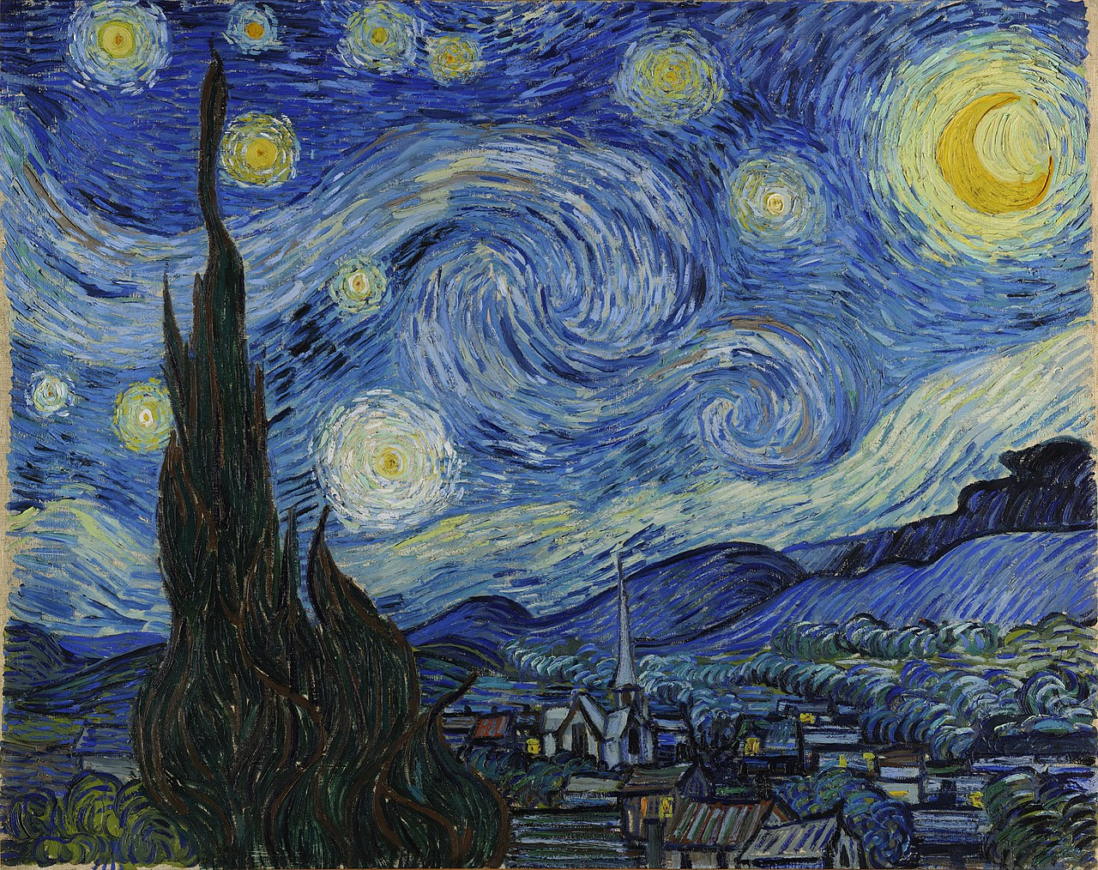

The Starry Night is an abstract landscape painting of the Dutch artist whose name is Vincent van Gogh. It is painted in June, 1889 and it was twelve months period. This painting was not the first original work of the artist. Just a year before, the artist painted his original Starry Night also known as Starry Night Over the Rhone, in Arles, France.[2] When he arrived France, he wanted to capture the lights of the sky so this painting became his first original artwork actually. Thus, he printed his first Starry Night with the view of the Rhone River. The size of the first Starry Night was a height of 72.5 cm and a width of 92 cm and it was in Paris, Musee d’Orsay.[3] The size of the latest painting has a height of 73.7 cm and a width of 92.1 cm and it is in Museum of Modern Art, New York City.[4] The artist uses a technique called impasto in which undiluted paint is applied with an immense thickness onto the canvas.[5] The materials used in the painting were oil paint colors and tubes, and canvas.[6]

The Starry Night (1889), it is an oil-on-canvas painting showing a tremendous night sky that has a small town below it. Immense night sky with chromatic blue swirls, a glowing yellow crescent moon, and stars are rendered like they are making a circular motion. There is also a couple of trees drawn strictly close to one another shown as flames. Trees having dark branches curling and swaying are on the left part of the painting. On the lower right, there is a small hillside village having a church and cottages. Squared shapes of houses considered as there is peace within the houses. [7]

The artist uses the Post-Impressionist style and focuses on luminescence which shows its strong effect in the sky parts which are tonal collections of blue and gold hues. When you look at it for the first time, the artist’s brush strokes come into the action and make your eyes move on the canvas. You immediately start to look at the details of the painting unconsciously. This makes the painting as an important artwork.

In the painting, there is a church in the middle of the painting which represents a religion. Moreover, the way that the artist uses to represent the sky, the stars and the moon is fascinating. It creates a vertigo when we look at it. We find ourselves in a whirlpool. The stars and the moon orbits in the sky. The planet Venus is also represented as a star while it was really bright. [8]

**Art Elements of Starry Night**

In Starry Night, the artist uses actual and horizontal lines to show the stars as swirling shapes. Also, the artist uses vertical lines to show some objects such as cypress tree and the church. The planet Venus and the stars can be seen as gestural lines because when we look at them, we see them as they move. The edges of the buildings in the painting also shows that there are some straight lines. He also uses some organic lines to show the swirling winds, hills and the sky. Curved and swayed lines are dominant. [9]

In Starry Night, the artist uses curving, swaying, organic shapes to illustrate the swirling winds, black tree, moon and stars, rolling hills. Also, those winds look like a circular shapes since they orbit and hillside villages look like some rectangular shapes. The windows look like rectangular. Moon is a circular shape.[10]

The artist uses intense light for example the night sky shining with bright stars, in the painting. Dark dominates the painting. There a little amount of light colors.

As a color, the artist uses blues, purples as a mixed color, yellows and whites. Blue and yellow have the crucial impact in the painting, mostly cool colors. Those colors are bold.

In Starry Night, The artist uses actual and rough texture which is impasto. Hills, small village and the sky are bold and getting lots of attention. The texture is mostly thick to indicate the shapes of the painting. The patterns are the type of following, ex: swirling winds. For example, the stars and the moon look like they are turning. The same patterns are repeated. The stars look like they are spirals. Curved lines help us to see the repeated patterns in the sky.

We can see the three-dimensional space by looking at several distinct layer such as cypress tree, the hills, the town itself, and the sky itself. They look like they are right behind the mountains and making circular motion. Furthermore, we can clearly see the two-dimensional areas which are the sky and the town. The sky has the huge space in the painting and the town has large amount of the field. Also, the tree looks like it almost reaches to the sky.[11]

In Starry Night, the repeated patterns make the winds almost move. The tree looks like it is burning as a flame and the winds flows in the sky with swirling motion. Thus, we can say that there is the implied motion (stopped time).

**Principles of Design**

In the painting, lines have the variety, curved, straight, horizontal and vertical. They create motion in the painting as well as colors. Colors also have the variety, blue, yellow, purple and white etc. Lines are repeated to create the variety. Moreover, the swirling brush strokes and an immense tones of cool colors creates the unity of the surface. This makes us see that everything is strictly related to one another. The picture looks like it is a whole, one belongs to another but it is not symmetric due to large amount of objects put separately in the painting. Mostly the blue and yellow colors are emphasized. The sky has the blue color intensively. The moon and the squared windows have the yellow color in large amount.

In terms of weight, the blue colored sky has the dominance. Bold and emphasized sky having the swirling winds, the stars, and the moon clearly get the attention in the first place. Small hillside village having lots of houses on the land has also lots of weight but not that much as the sky. The tree is much bigger than the houses, the moon, and the stars. In addition, mass and volume help us distinguish between the lines and the composition because the thick lines are great in number in the sky when compared to the ones in the land.

Since there are lots of repeated patterns in the sky such as swirling winds, the composition makes us virtually move in the painting. One line follows another and so do our eyes. We can directly follow the pattern. Also, we can track the rhythm by looking at the pattern of the tree. It looks like a burning flames having a twisted shape. Thus, our eyes follow the pattern and feel the rhythm.

**Conclusion Remarks and Opinions**

In Starry Night, the artist uses a technique called impasto to compose his work. The artist uses basic art elements such as prominent lines, shapes, color, light-value, pattern to create objects and clearly indicate them in the painting. Curving shapes represent the stars and the moon. Also, he uses curved and twisted shapes to create the tree object looking like a flame. Some straight lines used to create the houses of small hillside village by the artist. Moreover, the hill is composed of some curved lines. Most of the basic elements such as lines and shapes are composed with significant thickness. The sky in the painting has lots of repeated circular pattern that make us see them as they move. Whole painting is composed of cool colors, blue color dominates the painting and yellow follows. In the painting, since the artist uses lots of repeated patterns in the sky such as swirling winds, we can easily feel and follow the rhythm. For instance, the stars make circular motion. They are emphasized. Our eyes follow the lines and complete the objects. For example, the tree looks like it is burning like a flame.

**Conclusion- Part-2**

In my opinion, the artist uses basic art elements and principles of art effectively. He creates the objects by emphasizing them. When I look at the painting, I see a peaceful night with the stars, the moon orbiting around their center. There is the small hillside village shining with bright yellow colors indicating that there is a peace within them. I can feel the rhythm objects have repeated patterns such as swirling winds. One line follows another and so do my eyes. The cypress tree looks like it is burning as a flame. This got me by surprised because it has a twisted shape and does not look like a tree but it is a tree. The artist professionally uses the impasto technique because when I look at the painting, the whole picture does not look like it is complicated because of large amount of emphasized lines. The painting is rich in terms of variety of lines and colors. Lines are bold but does not distract my attention.

**References**

*Impasto Painting Technique*. (tarih yok). Impasto Painting: http://www.visual-arts-cork.com/painting/impasto-technique.htm adresinden alındı

*Starry Night Analysis*. (tarih yok). Retrieved from: https://www.artble.com/artists/vincent_van_gogh/paintings/starry_night/more_information/analysis

*Starry Night - Vincent Van Gogh*. (2013, May 13). Retrieved from: https://prezi.com/nrbhysjljgpy/starry-night-vincent-van-gogh/

*The Starry Night. Saint-Remy*. (no date). Crit Retrieved from: https://www.harding.edu/gclayton/2ddesign/crits/crit007_vangoghstarry.html

*Posts Tagged "The Starry Night"*. (2010, October 15). Artist: Present&Past Retrieved from: https://kentuckyartspeaks.wordpress.com/2010/10/15/artist-present-past-5/

*The Unknown*. (2011, September 20). Vincent Van Gogh - The Starry Night: http://the-unknown-camy.blogspot.com/2011/09/vincent-van-gogh-starry-night.html

*The Art Principles of "Starry Night"*. (2017, September 15). Retrieved from: https://ourpastimes.com/the-art-principles-of-starry-night-12551398.html

*The Starry Night By: Vincent Van Gogh*. (2013, October 1). Retrieved from: https://prezi.com/85rsfqmftxgu/the-starry-night-by-vincent-van-gogh/

*Zelazko, A*. (2017, September 20). The Starry Night. Retrieved from: https://www.britannica.com/topic/The-Starry-Night

Puchko, K. (2015, April 7). 11 Things You Didn't Know About The Starry Night. Retrieved from:

http://mentalfloss.com/article/62621/11-things-you-didnt-know-about-starry-night

1. The Starry Night Picture: https://www.britannica.com/topic/The-Starry-Night
2. Original Starry Night: http://mentalfloss.com/article/62621/11-things-you-didnt-know-about-starry-night
3. The information is taken from: http://www.musee-orsay.fr/en/collections/works-in-focus/search.html?no_cache=1&zoom=1&tx_damzoom_pi1%5BshowUid%5D=4081
4. Museum Information: https://www.moma.org/learn/moma_learning/vincent-van-gogh-the-starry-night-1889/
5. Impasto technique definition: http://www.visual-arts-cork.com/painting/impasto-technique.htm
6. Materials: http://site.artsheaven.com/blog/vincent-van-gogh-painting-style-and-techniques/
7. The painting information is taken from: https://www.britannica.com/topic/The-Starry-Night
8. Venus information: https://www.theartpostblog.com/en/the-starry-night-by-van-gogh-what-it-represents/
9. Line information: https://www.harding.edu/gclayton/2ddesign/crits/crit007_vangoghstarry.html
10. Shapes: https://www.harding.edu/gclayton/2ddesign/crits/crit007_vangoghstarry.html
11. Space- 3D-2D: https://www.harding.edu/gclayton/2ddesign/crits/crit007_vangoghstarry.html